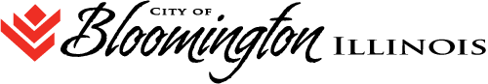
HUMAN RELATIONS COMMISSION REGULAR AGENDA
109 E. OLIVE STREET. Bloomington, IL
Council Chambers

WEDNESDAY, DECEMBER 12, 2018 at 6:00 P.M.

- Call to Order
- Roll Call of Attendance
- Public Comment
- Approval of Minutes:
  - Consideration of approving the minutes of the Human Relations Commission Special Meeting of Monday November 19, 2018.
  - Move to closed session for consideration of approving the minutes of the Closed Session meeting of November 19, 2018
- Agenda Items
  - Progress report on MLK Event activity

- Old Business
Status of discrimination complaint

- New Business
Ticket distribution to Commissioners

- Next Scheduled Meeting Date: January 9, 2019

- Adjournment

